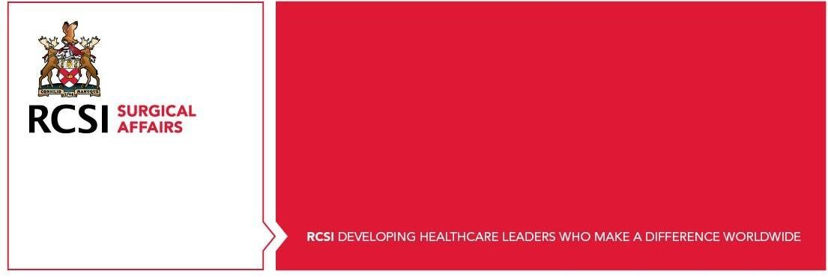
Basic Surgical Principles and Practice Certificate (BSPP) - General FAQ’s
Who can apply for the Basic Surgical Principles and Practice Certificate:
To be considered eligible for the programme, you must be:
- Registered on Continuous Professional Development Support Scheme (CPD_SS)
- Work within the Public Health Service
- a Surgical SHO

How do you apply for this program?

To apply please fill out the application form. The closing date for 2023 applications is the 24 August 2023.

What is the structure of this Certificate?

This is a one-year, part-time program delivered between September 2023 and June 2024.
The mode of learning will be 80% online and 20% in-person. Classes take place in the evening for one or two hours, once a week.

Is there any funding for this program?

Yes, the cost of this programme is €2,240.00, all of which is covered thought the training funds that are available to NCHD’s from the HSE.
- €990.00 is covered via the NCHD CPD funding which will be claimed directly from the HSE on behalf of the NCHD’S.
- The remaining balance of €1,250.00 which must be paid for the NCHD can be covered by the Training Support Scheme (TSS). A fund NCHDs will claim back directly from their hospitals TSS fund, this has been approved by HSE NDTP.

How can I manage payment for this certificate?

Payment can be made in instalments and the HSE have committed to pay any claims by the NCHD within 4 weeks of receipt. For further information on this please email spp@rcsi.ie.
Candidates may qualify for tax relief on fees paid and further information is available at revenue.ie

