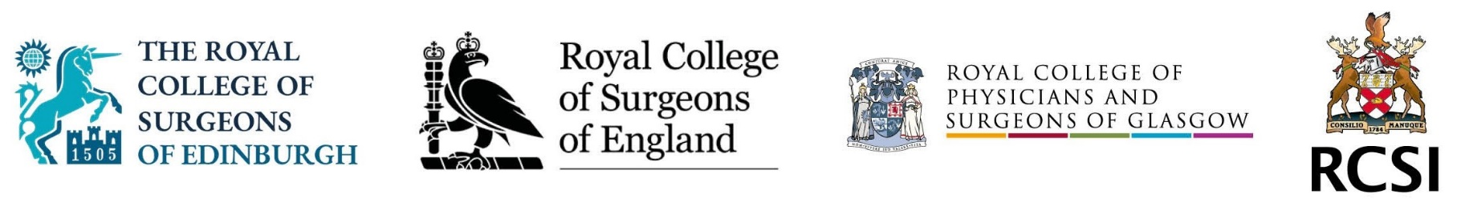

Internal QA Committee Chair – Job Description

The Internal Quality Assurance Committee Chair reports to the Intercollegiate Committee for Basic Surgical Examinations (ICBSE) and is responsible for monitoring and reviewing all components of the MRCS and DO-HNS examinations to ensure that the highest possible standards are achieved, making recommendations for improvements in the case of any deficiencies. The Committee is charged with ensuring that the examinations are fit for purpose and meets the GMC Excellence by Design; Standards for Postgraduate Curricula (GMC May 2017). The duties of the Committee are set out in detail in the Terms of Reference.

The key responsibilities of the Chair are:

- To provide leadership for the IQA and to act as its spokesperson at ICBSE meetings
- To chair meetings of the IQA (held three times p.a. in London, Edinburgh, Glasgow and Dublin by rotation)
- To resolve urgent matters between meetings, liaising with the ICBSE Chair and the ICBSE administration as appropriate
- To act as the key point of advice for the ICBSE administration and Heads of Examinations on QA matters
- To ensure that the ICBSE and its sub-committees receive and act on QA recommendations in a timely manner
- To work with the Lead Assessor on Assessor training days
- Additional input on a weekly basis will be required to read and prepare relevant material and communicate with members of the ICBSE team

The IQA Chair will be appraised annually by the ICBSE Chair.

On average, the meeting time commitment (in addition to the regular input/advice to ICBSE and Colleges) will be approximately 10 days p.a. as follows:

- Chairing IQA meetings (3 days p.a.)
- Attending ICBSE meetings (3 days p.a.)
- Running assessor training days (1 day p.a.)
- Occasional other duties (3 days p.a.)

For an informal discussion of these duties, please contact: John Hines on jhines@rcseng.ac.uk or Greg Ayre, ICBSE Manager, on gayre@icbse.org.uk.

