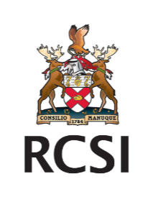

MRCS Part B Preparation Course – Cairo, Egypt – February 2024

Programme outline
RCSI Cairo MRCS Part B Preparation Course
Date: Wednesday February 21st
Location: AFCM Hospital Education Centre
Faculty:
- Prof Ahmed Makki
- Prof Peter Gillen
- Eamon Mackle
- Clinical Actors
Learning outcomes:
This focused and immersive 1-day preparation course will focus on the mechanisms of the exam to help candidates better prepare for the Part B OSCE. The programme will also focus on elements of the Part B OSCE that previous candidates have informed us they find to be the most challenging for them. In the second half of the day we present a number of Clinical scenarios mapped to the MRCS curriculum in an “OSCE Fishbowl” setting with actors and experienced MRCS examiners.
Timetable:
9.30 Welcome and outline of course objectives
9.45 How the exam works and marking of stations
10.15 Physical examination station preparation
11.00 COFFEE BREAK
11.30 Clinical communication skills training
1.0 pm LUNCH BREAK
2.0-4.30 “Fishbowl OSCE exercises” with multiple clinical scenarios
4.30-5.0pm Session debrief.
All candidates for this course will get 1 years Affiliate membership of RCSI which includes a suite of additional supports to help prepare for MRCS Part B.
Discounted Price for registered Cairo RCSI Exam candidates:
10th of January to 15th January 13:00- €250
Normal Price:
15th of January onwards €320

