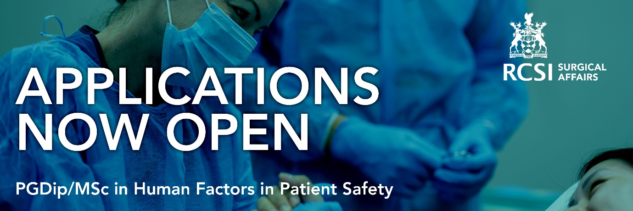

Dear x,

Hope you are keeping well.

We’re delighted to advise that RCSI’s innovative part-time postgraduate programme in Human Factors in Patient Safety is now available to complete in one year as a Postgraduate Diploma or over two years as a Postgraduate Master’s Degree. The progamme is now delivered fully online and the programme brochure can be viewed here.

This programme supports candidates who wish to become experts in delivering patient safety and quality improvement initiatives in acute hospitals. The programme is positioned at level 9 on the NFQ and is a fully inter-professional programme developed to meet the needs of Surgeons, Anaesthetists, EM doctors, Nurses, Nurse Educationalists and other health care professionals.

The programme is now open for enrollment and will commence as scheduled in September 2021. Applications are reviewed weekly and places allocated on a first come first served basis for suitable applicants so it's advisable to apply as early as possible to avoid disappointment.

You can find out more about the programme from the attached flyer or by clicking here to register your interest, request a call or read testimonials from graduates of the programme.

The Human Factors team at RCSI Surgical Affairs would be delighted to hear further from you at MScHumanFactorsPS@rcsi.ie if you should have any queries or questions.

Regards,

RCSI Surgical Affairs

